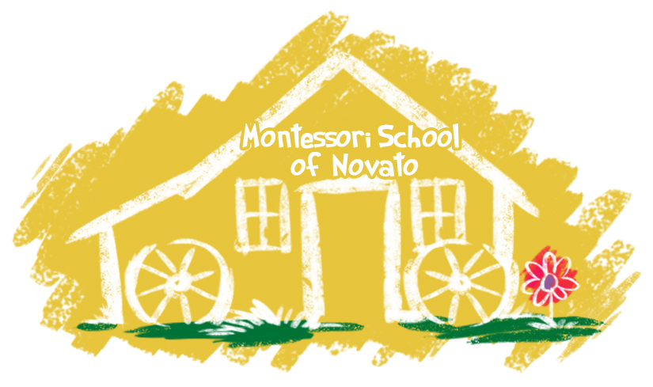

1466

1466 S.

www.novatomontessori.com

April

Novato Montessori

2013/14

1466 S. Novato Blvd.

Novato, CA 94947

892-2228

[sue@novatomontessori.com](mailto:sue@novatomontessori.com)

License #213000400

Important Dates:

* April 9 – 13 Spring Break School closed- daycare offered
* May 3- Spring Open House 5 :00 – 6:30
* May 28- Memorial Day School Closed
* June 8- Last Day of School Family Picnic at Miwok Park 6:00
* June 11 – Aug. 10 Summer School
* Aug. 13-24 School Closed
* Aug. 27 First Day of School



**Adopt** **a** **Tree**

**Taking care of the planet is a natural during the month of April when we celebrate Earth Day. An excellent activity to reinforce ecology lessons is to adopt a tree with your child. Following is a list of things you can do together:**

**Name the tree.**

**Take a picture of the tree**

**Measure the height and width of the tree**

**Draw a picture of the tree**

**Make up a story about the tree**

**Observe the tree through the seasons**

**Collect seeds and leaves from the tree**

Spring Open House

Thursday, May 3 5:00 –6:30PM

This is a chance for you to come for a visit and have your child show you all of the work she/he has done in the classroom this year. In order to make things less crowded and easier for the children to show you their work we are going to ask that you come between specific times. We will send you a note with your time to come. Please follow your specific time frame. There will be parking across the street at Quest Church.

Picnic

Our End of the Year picnic will be at Miwok Park on Friday, June 8 at 6:00. A sign-up sheet for the food you would like to contribute will be emailed closer to the date.

### Practical Life at Home

C:\Users\Sue\AppData\Local\Microsoft\Windows\Temporary Internet Files\Content.IE5\O81JB2QU\MM900283894[1].gif

Children learn by doing. Practical Life is all about teaching a child how to take care of the environment and himself. Children enjoy repetitively practicing real-life things. Give your child the real-life experience of folding socks into pairs, polishing shoes, sorting utensils, setting the table and folding clothes out of the dryer. Children will spend many happy hours with a button box filled with a variety of buttons, sorting them into different colors, shapes and sizes. This is a perfect example of how you can take everyday objects (the more beautiful and interesting the better) to get your child involved. Some of the best learning experiences come from the mundane and ordinary efforts of life, giving children the opportunity to exercise their minds and their motor skills.

Use Encouragement, not rewards or treats….

Have you ever offered your child a trade-off if she completed a task? This is often tempting and can have a short-term effect. But consider the message you are giving. When you use external rewards to motivate your child, she learns that there is no intrinsic value to the activity, and the only reason to do it is for the reward.

Encouragement and maybe some help from you is all that is needed if a task is worth doing. It should have value for its own sake. Comments such as, “You worked hard on this,” or “You did this all by yourself,” are the reward they appreciate and learn from.



