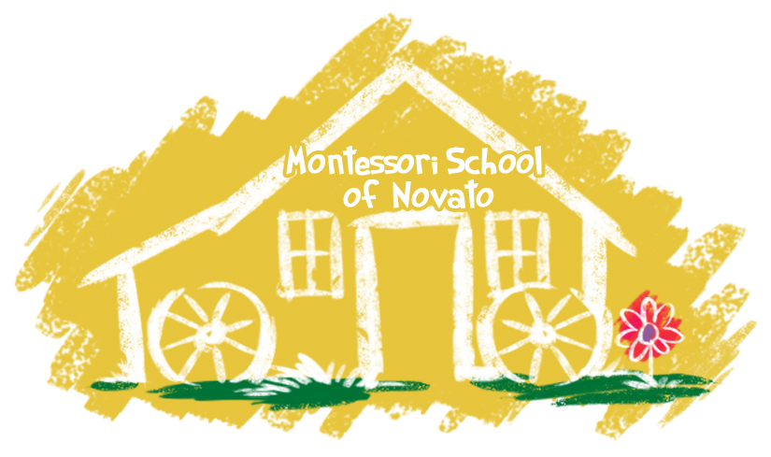

1466

1466 S.

www.novatomontessori.com

April

Novato Montessori

Spring Open House

**Important Dates**:

* April 8– 12 Spring Break School closed- daycare offered
* May 9- Spring Open House 5 :00 – 6:00
* May 27- Memorial Day School Closed
* June 7- Last Day of School Family Picnic at Miwok Park 6:00
* June 10 – Aug. 9 Summer School
* Aug. 12-23 School Closed
* Aug. 26 First Day of School

Thursday, May 9th 5:00 –6:00 PM

This is a chance for you to come for a visit and have your child show you the new lessons they have been receiving. In order to make the classrooms less crowded and easier for the children to show you their work we are going to ask that you sign up for 5-5:30 or 5:30-6. Sign up sheets will be by each classroom computer on May 1st. Please follow your specific time frame.



### Practical Life at Home

C:\Users\Sue\AppData\Local\Microsoft\Windows\Temporary Internet Files\Content.IE5\O81JB2QU\MM900283894[1].gif

Children learn by doing. Practical Life is all about teaching a child how to take care of the environment and himself. Children enjoy repetitively practicing real-life things. Give your child the real-life experience of folding socks into pairs, polishing shoes, sorting utensils, setting the table and folding clothes out of the dryer. Children will spend many happy hours with a button box filled with a variety of buttons, sorting them into different colors, shapes and sizes. This is a perfect example of how you can take everyday objects (the more beautiful and interesting the better) to get your child involved. Some of the best learning experiences come from the mundane and ordinary efforts of life, giving children the opportunity to exercise their minds and their motor skills.

Use Encouragement, not rewards or treats….

Have you ever offered your child a trade-off if she completed a task? This is often tempting and can have a short-term effect. But consider the message you are giving. When you use external rewards to motivate your child, she learns that there is no intrinsic value to the activity, and the only reason to do it is for the reward.

Encouragement and maybe some help from you is all that is needed if a task is worth doing. It should have value for its own sake. Comments such as, “You worked hard on this,” or “You did this all by yourself,” are the reward they appreciate and learn from.

Reminders:

*Please bring in an emergency earthquake kit

* Slow down in the parking lot and keep to the right as your exit

*Check your child’s extra clothing bag to make sure the items fit and are appropriate for the warmer weather



